Eileen Seefluth
Creative Writing Package
2024

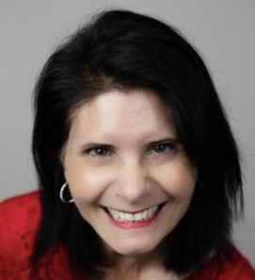
Introduction
Hello. My name is Eilee Seefluth. I am T.H.E. Copywriter: Therapeutic, Humanitarian, and Empowering and Encouragement as well as an Educational Writer.
- Therapeutics:
Poetry and healing for counseling offices as well as human resources for employees to receive wellness benefits.
- Humanitarian:
Nonprofits, campaigns, and commercial writing.
- Empowering:
Write copy through broadcasting, letters, ads, copy, and grants.
Services
- Creative Writing | - Broadcast Writing | - Educational Writing
- Empowering Writing | - Therapeutic Writing | - Grant Writing
- Editing | - Proofing | - Voice Overs

Broadcast Writing
Grant Writing
Educational Writing
Empowering Writing
Therapeutic Writing
Editing
Proofing
Voice Overs
My Story
Growing up on the west coast I always loved writing, including on the walls and even the bed sheets.
My personality is expressive and with imagery on paper (and off). As a middle child, I loved to be heard.
After earning both my broadcasting and communication degrees, I added to my life experiences.
I combined my encounter with domestic abuse and my passion for writing and voicing to empowering others into a fulltime freelance
writer.
So, with having worked in both radio and television, the airlines, case study work with women who have been affected by domestic
abuse, I became (T.H.E.) a freelance writer which means: Therapeutic, Humanitarian, and Empowering, Encouraging, Educational.
Mission
Writing, editing, proofing, voicing for those who need encouragement, see value in therapeutics words, building empowerment in people
and places through prose, poetry, broadcast copy, grants, and web content.
Values
Integrity with fruits of the spirit (love, joy, peace, patience, kindness, goodness, faithfulness, gentleness, and self-control) servicing all
your business and organizational writing needs with a passionate heart.
Contact www.EileenSeefluth.com from your URL | 918.407.7106
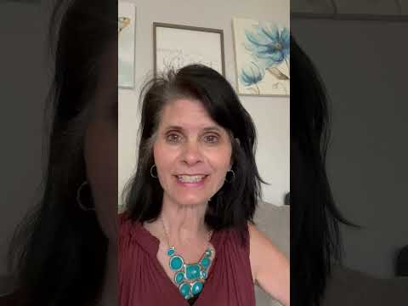
Call me for a FREE 30-minute consultation 918.407.7106
Eileen Seefluth , Award-Winning Speechwriter Toastmasters Int’l| Author of 2 book

